**Assignment 3**

1-Generate Binary Numbers

* Generate the first n binary numbers using a queue.
* Input: n = 5
* Output: 1, 10, 11, 100, 101

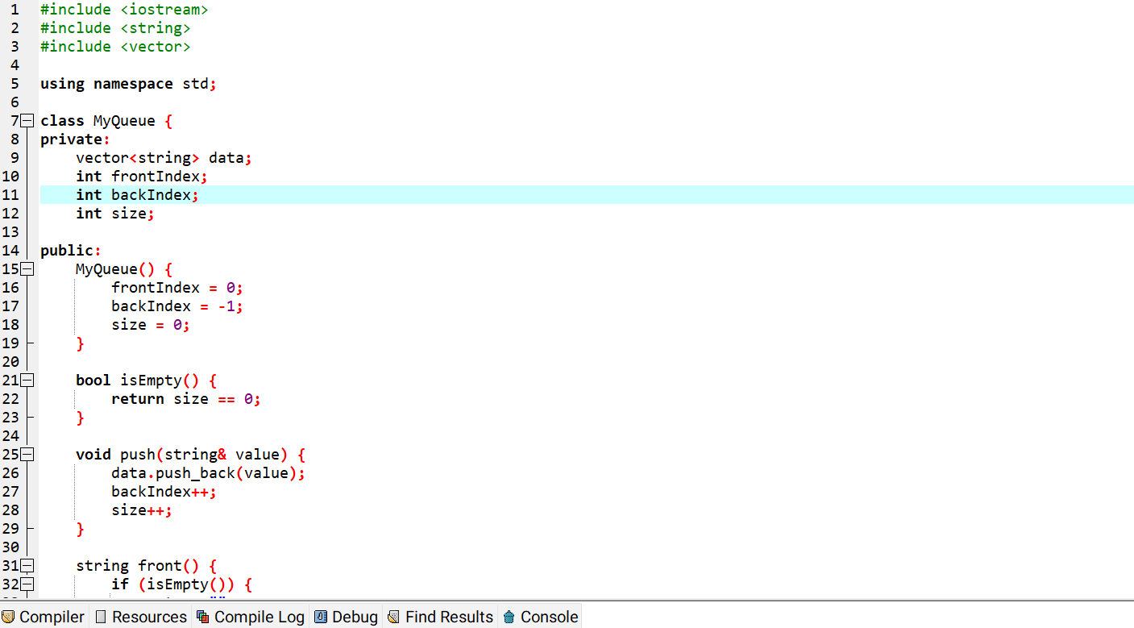

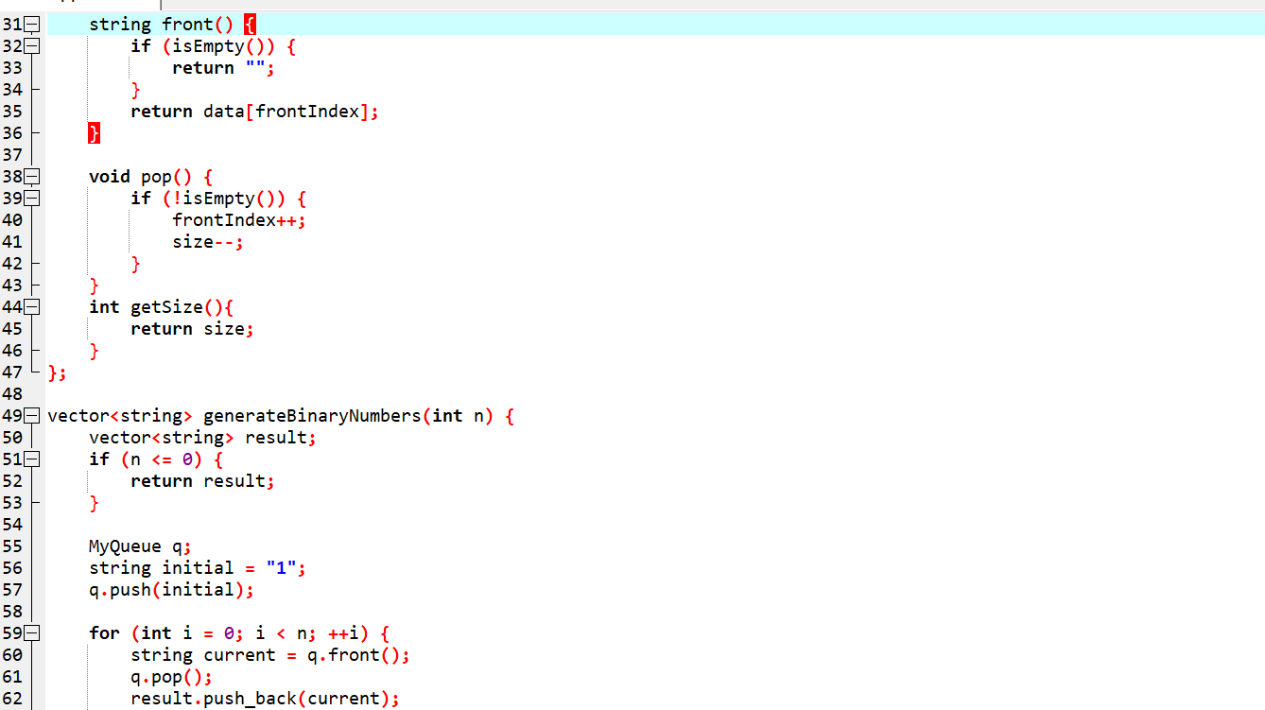

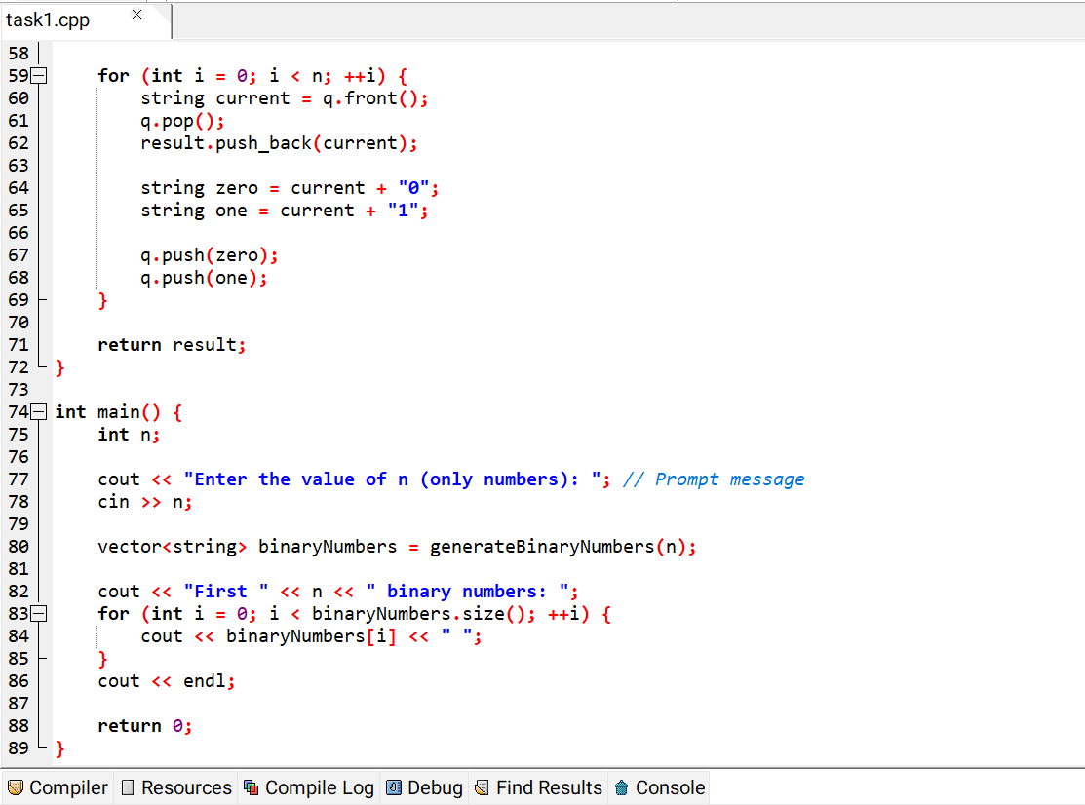

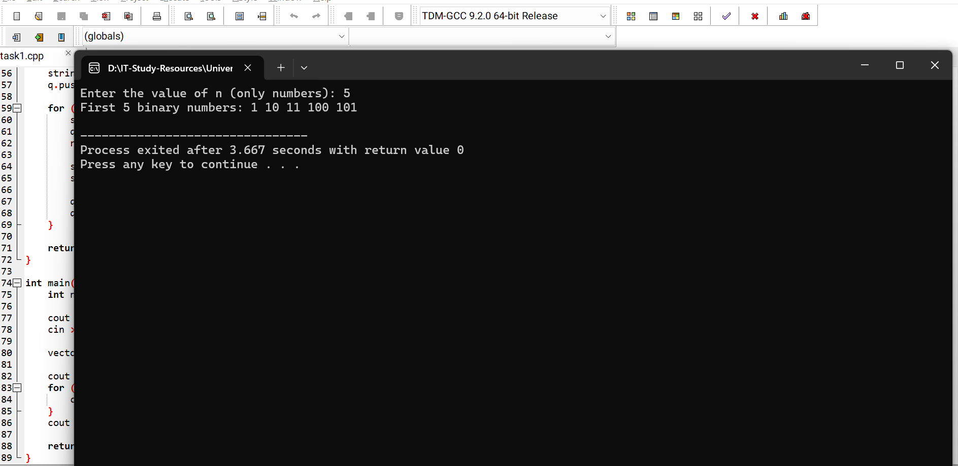

2- Interleave the First Half and Second Half of a Queue

* For example: Input queue: 1, 2, 3, 4, 5, 6, Output: 1, 4, 2, 5, 3, 6.

